SYSC 2310 A Introduction to Digital Systems

Lab Report

Lab #4: Gate-Level Minimization

Student Name: Riya Arora

Student ID: 101190033

TA Name: Ramy Mohamed

Lab Section: L2E

Lab Section

Lab Date: November 8th, 2021

Date Completed: November 14th, 2021

**Pre-Lab**

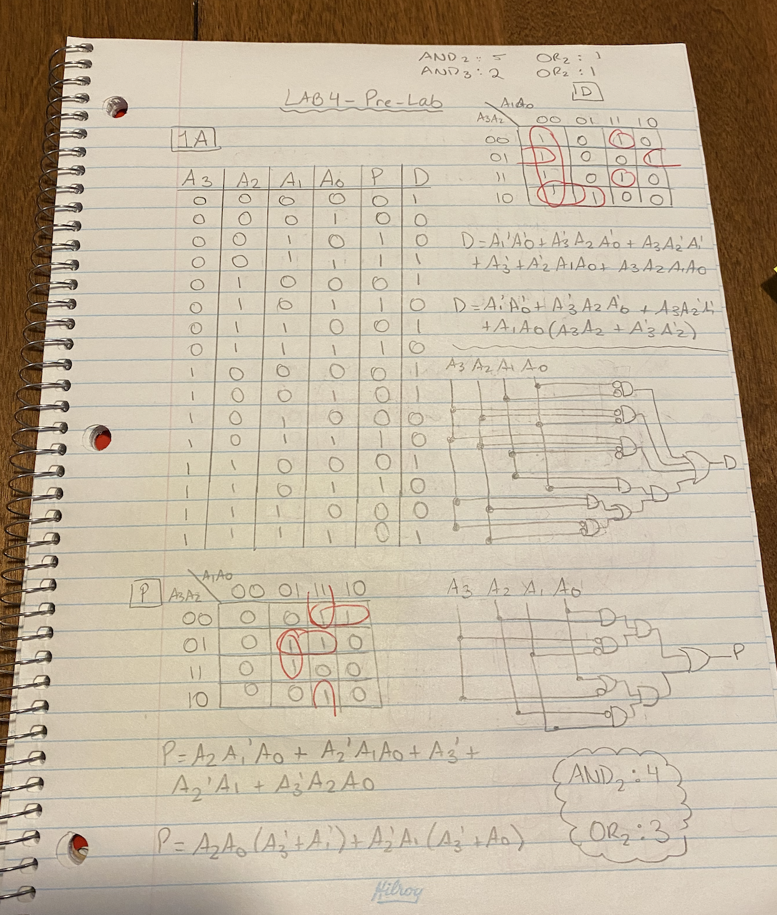

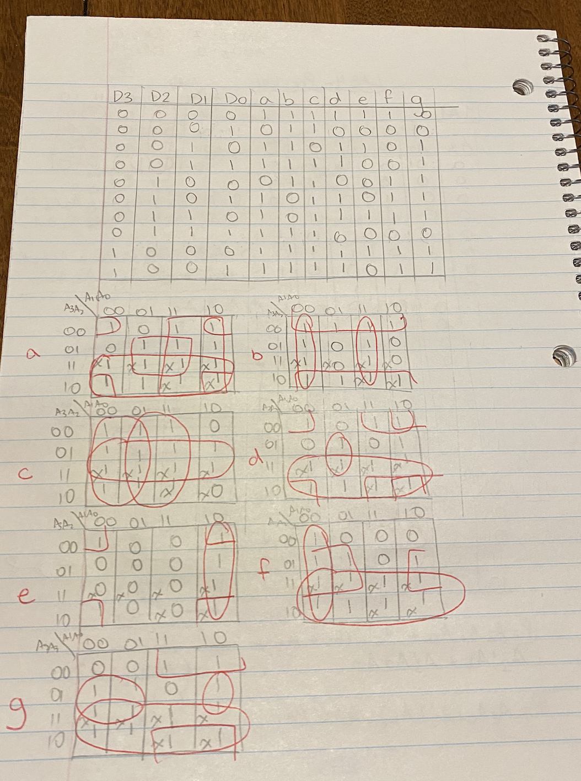

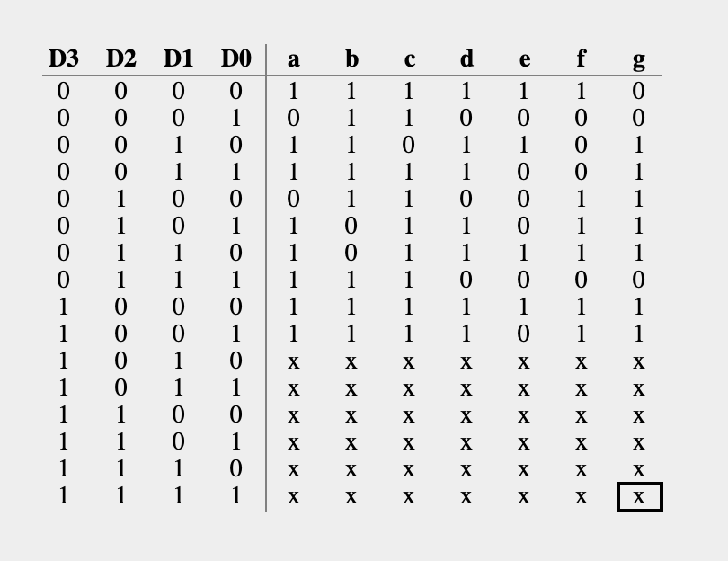

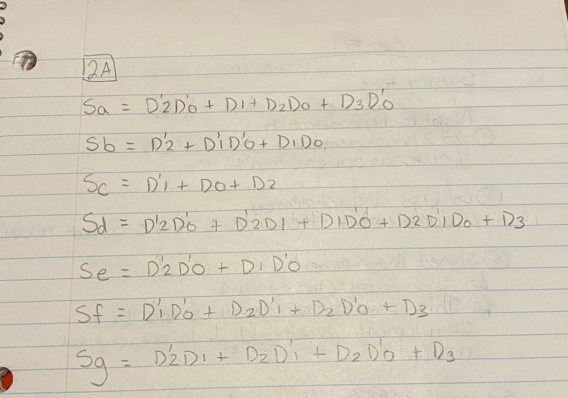

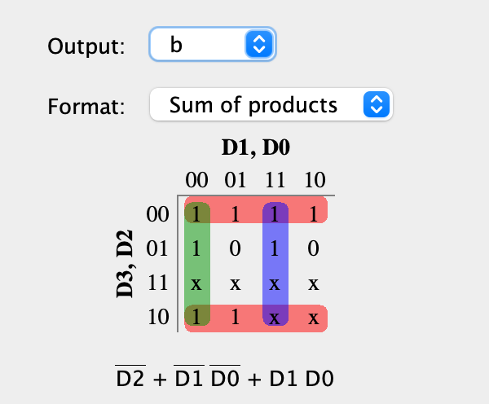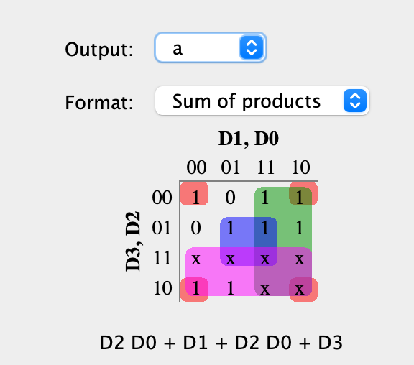

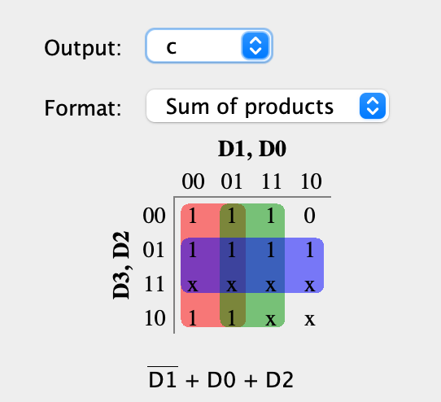

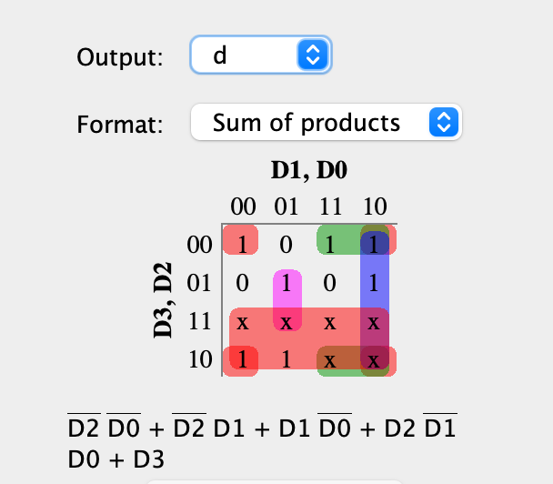

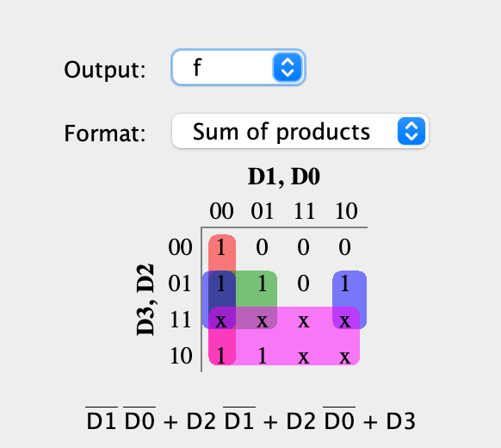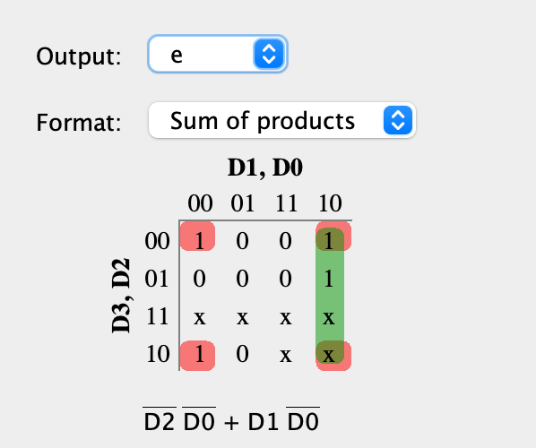

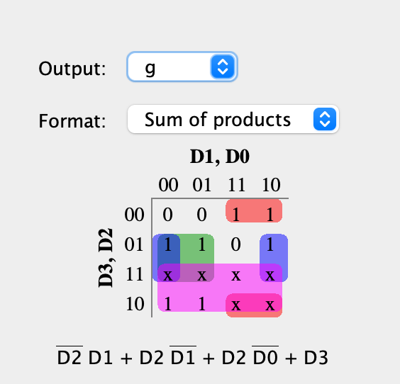

**Exercise 1**

a. Equations Used for the Design

P = A2A1’A0 + A2’A1A0 + A3’A2’A1+A3’A2A0

D = A1’A0’+A3’A2A0’+A3A2’A1’+A3’A2’A1A0+A3A2A1A0

b. Circuit Design

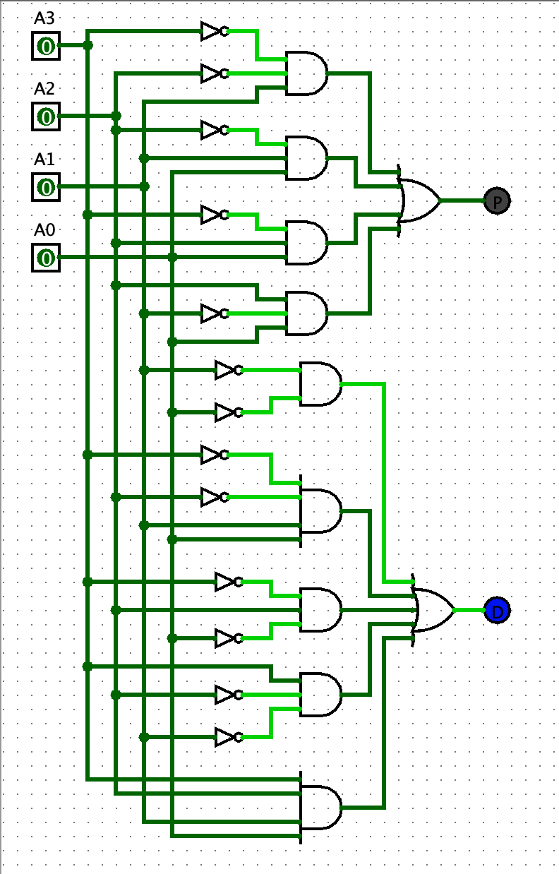

c. Logging file Results

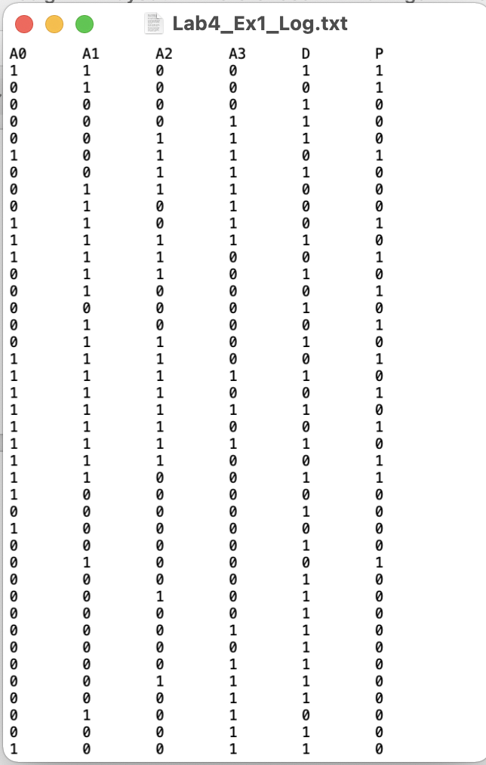

d. Comments

Circuit Design and Logging File above.

**Exercise 2**

a. Equations Used for the Design

Sa = A3+A1+A2A0+A2’A0’

Sb = A2’+A1’A0’+A1A0

Sc = A1’+A0+A2

Sd = A2A1’A0+A2’A0’+A3+A1A0’+A2’A1

Se = A2’A0’+A1A0’

Sf = A3+ A1’A0’+A2A0’+A2A1’

Sg = A3+A2A1’+A2A0’+A2’A1

b. Circuit Design

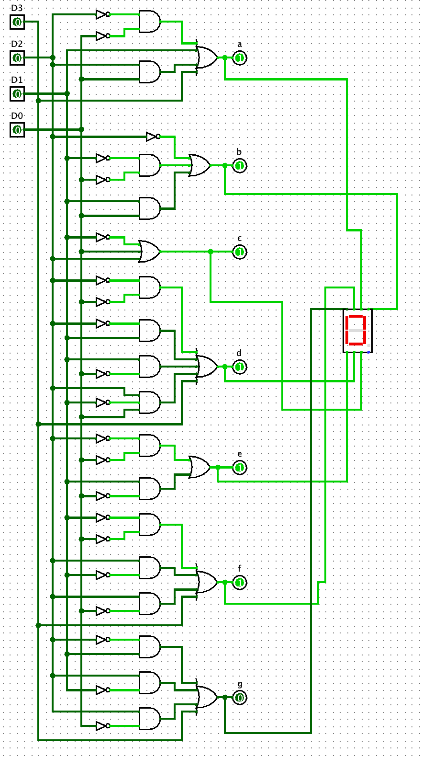

c. Logging file Results

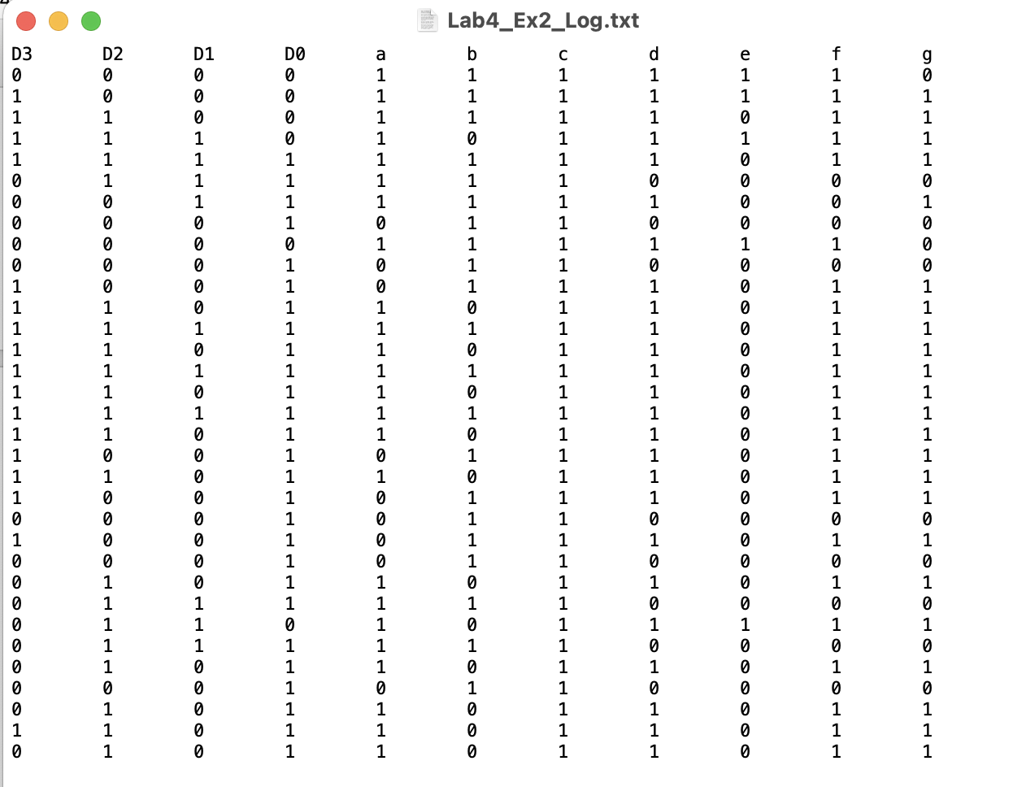

d. Comments

Circuit Design and Logging File above.